SMS-Food-Service Mobile Team

First Steps

* You will need to install and setup the developer environment (Android Studio, MySQL, Visual Studio 2017, Git)
* Be sure your Android Studio is up to date
* Follow environment document and compile program using the GalaxyNexus emulator. There may be issues if you work with other emulators, not entirely sure though.

Tutorials Used

It may be helpful for the future developers to know what tutorials were used so here they are:

* Menu: <https://www.youtube.com/watch?v=AS92bq3XxkA>
* Claimable Packages: <https://www.youtube.com/watch?v=FKUlw7mFXRM>
* HttpURLConnections: <https://medium.com/@lewisjkl/android-httpurlconnection-with-asynctask-tutorial-7ce5bf0245cd>

Menu Options

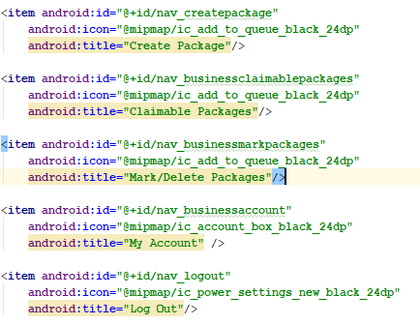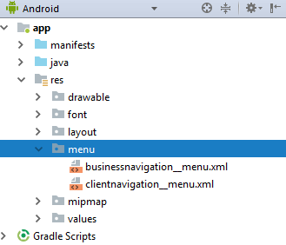To add menu options, you’ll have to go to the menu directory and change the items.

Then, you just have to go to the corresponding menu activities and add/remove/modify the switch cases.

Tips

* Refer to API as you’re programming so you know what fields are needed
* Use Google/StackOverFlow